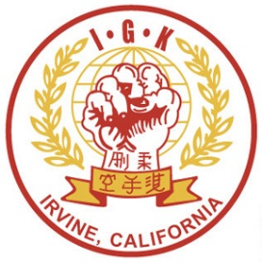

**Saturday, December 8th, 2018 9:30am-noon  
Deerfield Community Park**

**POTLUCK SIGN UP SHEET (Please bring for 12)**

**Main Course: Side Dish:**

**Salad: Dessert:**

**Drinks:**

***Thank You.***

**Orange County Irvine Goshin Kai**

**End of Year Celebration**